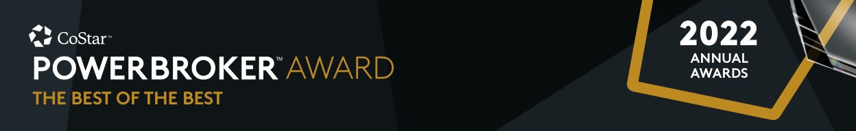

For Immediate Release

**2022 CoStar Power Broker Award Winners Announced!**

[Month XX, 2023] – (CITY, ST) – CoStar Group, Inc., a leading provider of commercial real estate information, analytics and online marketplaces, announced today the recipients of the 2022 CoStar Power Broker Award, recognizing professionals and firms who closed the highest transaction volume in commercial real estate deals in their respective markets.

In (market), (winner(s) name(s)) of (company) have been recognized as the most active local dealmakers with the prestigious industry award.

The CoStar Power Broker Award program has honored the industry’s elite for 23 years. Please help us in congratulating (name/or names) on their 2022 CoStar Power Broker Award in (award name) (market).

# # #

**About CoStar Group, Inc.**

CoStar Group, Inc. (NASDAQ: CSGP) is the leading provider of commercial real estate information, analytics and online marketplaces. Founded in 1987, CoStar conducts expansive, ongoing research to produce and maintain the largest and most comprehensive database of commercial real estate information. Our suite of online services enables clients to analyze, interpret and gain unmatched insight on commercial property values, market conditions and current availabilities. STR provides premium data benchmarking, analytics and marketplace insights for the global hospitality sector. Ten-X provides a leading platform for conducting commercial real estate online auctions and negotiated bids. LoopNet is the most heavily trafficked commercial real estate marketplace online. Apartments.com, ApartmentFinder.com, ForRent.com, ApartmentHomeLiving.com, Westside Rentals, AFTER55.com, CorporateHousing.com, ForRentUniversity.com and Apartamentos.com form the premier online apartment resource for renters seeking great apartment homes and provide property managers and owners a proven platform for marketing their properties. Homesnap is an industry-leading online and mobile software platform that provides user-friendly applications to optimize residential real estate agent workflow and reinforce the agent-client relationship. Homes.com offers real estate professionals advertising and marketing services for residential properties. CoStar Group’s websites attract tens of millions of unique monthly visitors. Headquartered in Washington, DC, CoStar maintains offices throughout the U.S. and in Europe, Canada and Asia with a staff of approximately 4,900 worldwide, including the industry’s largest professional research organization. For more information, visit www.costargroup.com.